





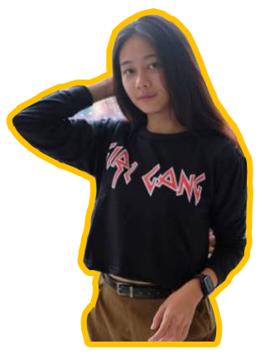
contact@merlyn-hy.com
twitter.com/merlyn
facebook.com/merlyn
Instagram.com/merlyn
Contacts
Experience
2019 Video Editor
Metro TV
2018 Professional Photographer
PT. Multimedia, Tbk

Software
Adobe
InDesign
Adobe
Lightroom
Adobe
Premier Pro
Adobe Illustrator
Adobe Photoshop
S1 Broadcasting
Jl. Kapten Tendean No. 25
Jakarta Selatan, 10200
+62 123 456 7890
28/06/1995
S2 Magister Desain
About me
Fill about you here _______
_______________
_______________
_______________
_______________
_______________
PHOTOGRAPHER
&
DESIGNER

