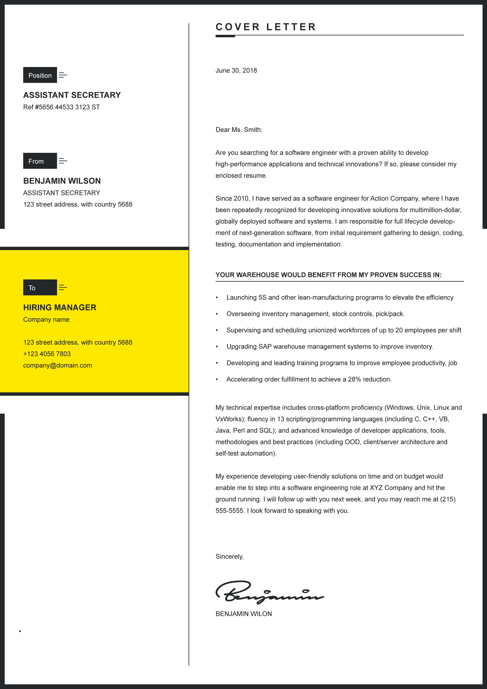
COVER LETTER
YOUR WAREHOUSE WOULD BENEFIT FROM MY PROVEN SUCCESS IN:
Dear Ms. Smith:

Are you searching for a software engineer with a proven ability to develop high-performance applications and technical innovations? If so, please consider my enclosed resume.

Since 2010, I have served as a software engineer for Action Company, where I have been repeatedly recognized for developing innovative solutions for multimillion-dollar, globally deployed software and systems. I am responsible for full lifecycle development of next-generation software, from initial requirement gathering to design, coding, testing, documentation and implementation.
To
From
Position
My technical expertise includes cross-platform proficiency (Windows, Unix, Linux and VxWorks); fluency in 13 scripting/programming languages (including C, C++, VB, Java, Perl and SQL); and advanced knowledge of developer applications, tools, methodologies and best practices (including OOD, client/server architecture and self-test automation).
My experience developing user-friendly solutions on time and on budget would enable me to step into a software engineering role at XYZ Company and hit the ground running. I will follow up with you next week, and you may reach me at (215) 555-5555. I look forward to speaking with you.

Sincerely,

BENJAMIN WILON
- Launching 5S and other lean-manufacturing programs to elevate the effi

- Overseeing inventory management, stock controls, pick/pack.

- Supervising and scheduling unionized workforces of up to 20 employees

- Upgrading SAP warehouse management systems to improve inventory.

- Developing and leading training programs to improve employee

- Accelerating order fulfillment to achieve a 28% reduction.

June 30, 2018
HIRING MANAGER
Company name

123 street address, with country 5688
+123 4056 7803
company@domain.com
BENJAMIN WILSON
ASSISTANT SECRETARY
123 street address, with country 5688
ASSISTANT SECRETARY
Ref #5656 44533 3123 ST

