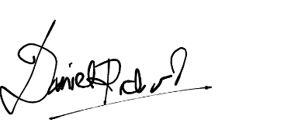

Sincerely,

Daniel Richard

Dear Mr. Than:

I am applying to your Digital Marketing Specialist position at Foundry Marketing. As an experienced digital marketer, I have the knowledge, creativity, and business skills needed to successfully market a client's brand.

My skillset includes the following: social media management, knowledge of SEO implementation, proficiency at graphic design, familiarity with HTML and CSS, website management and experience in executing digital marketing campaigns for brands. For five years, I was self-employed as a social media manager for a variety of clients. At one point, I produced content for 15 social media accounts. My biggest online presence was on Twitter, with one of my account's accumulating over 20,000 followers. My marketing strategies were always designed to entice the client's target audience.

I also have basic experience in running websites for brands; in today's market, having a functional and attractive website is a key part of running a successful marketing campaign. In addition, I am familiar with various business strategies targeted at growing an online presence. As a marketer, I understand the importance of developing relationships in order to foster loyalty among customers. I am able to implement a wide range of strategies for branding purposes, especially when it comes to improving a client's social media presence and search engine optimization.

Thank you for your time in considering me for your Digital Marketing Specialist position. I would enjoy working for a highly esteemed digital marketing firm such as yours, and I feel that I'd be a qualified fit for this role.

**DANIEL**

**richard**

*+62 21 9090 1234*

*gerald@gmail.com*

*Jl. Garuda Kav. 121 No. 45, Jakarta, ID*

TO

**HIRING MANAGER**

MR. GERALD THAN

August 25, 2022

**COVER LETTER**

**CONTACTS**

**PHONE** : +62 274 9090 1234

**EMAIL** : daniel@gmail.com

**WEB** : www.daniel.com

Jl. Palagan No. 233,

JOGJA, ID

DIGITAL MARKETER