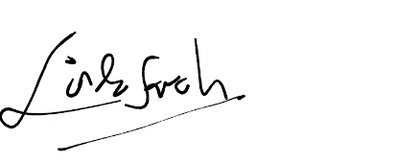

Sincerely

LINDA SARAH

Dear Mr. Lian:

I am writing to apply for the Email Marketing Specialist position that was recently advertised on the company website. I am confident that I have the skills and experience that you are looking for, and I believe that I would be a valuable asset to your team.

I have over three years of experience in the email marketing industry, and during that time I have developed a strong understanding of the principles of effective email marketing. I am an expert in using email marketing software such as MailChimp, and I have a proven track record of creating successful email marketing campaigns that generate results.

I am also an expert in using data to optimize email marketing campaigns. I understand the importance of using data to understand what works and what doesn’t, and I have the skills to analyze data and use it to improve email marketing campaigns.

I am confident that I have the skills and experience that you are looking for, and I would be grateful for the opportunity to discuss my qualifications with you in more detail. Thank you for your time and consideration.

Jl. Palagan No. 233, JOGJA, ID

Cover Letter

TO

**HIRING MANAGER**

MR. BERRY LIAN

+123 4056 7803

company@domain.com

123 street address, with country 5688

August 25, 2022

**JOB REFERENCE #456543**

+62 274 9090 1234

linda@domain.com

Linda Sarah

EMAIL MARKETER