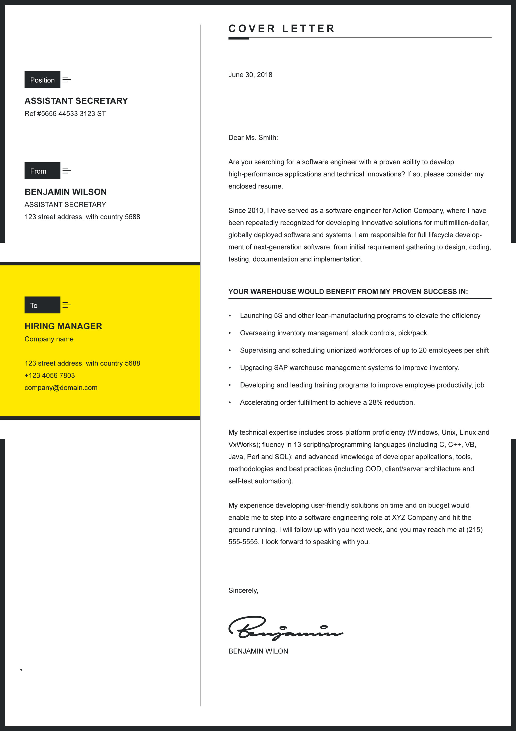

**COVER LETTER**

**YOUR WAREHOUSE WOULD BENEFIT FROM MY PROVEN SUCCESS IN:**

Dear Ms. Smith:

Are you searching for a software engineer with a proven ability to develop high-performance applications and technical innovations? If so, please consider my enclosed resume.

Since 2010, I have served as a software engineer for Action Company, where I have been repeatedly recognized for developing innovative solutions for multimillion-dollar, globally deployed software and systems. I am responsible for full lifecycle development of next-generation software, from initial requirement gathering to design, coding, testing, documentation and implementation.

To

From

Position

My technical expertise includes cross-platform proficiency (Windows, Unix, Linux and VxWorks); fluency in 13 scripting/programming languages (including C, C++, VB, Java, Perl and SQL); and advanced knowledge of developer applications, tools, methodologies and best practices (including OOD, client/server architecture and self-test automation).

My experience developing user-friendly solutions on time and on budget would enable me to step into a software engineering role at XYZ Company and hit the ground running. I will follow up with you next week, and you may reach me at (215) 555-5555. I look forward to speaking with you.

Sincerely,

BENJAMIN WILON

* Launching 5S and other lean-manufacturing programs to elevate the effi
* Overseeing inventory management, stock controls, pick/pack.
* Supervising and scheduling unionized workforces of up to 20 employees
* Upgrading SAP warehouse management systems to improve inventory.
* Developing and leading training programs to improve employee
* Accelerating order fulfillment to achieve a 28% reduction.

June 30, 2018

**HIRING MANAGER**

Company name

123 street address, with country 5688

+123 4056 7803

company@domain.com

**BENJAMIN WILSON**

ASSISTANT SECRETARY

123 street address, with country **5688**

**ASSISTANT SECRETARY**

Ref #5656 44533 3123 ST